How Do You Make a Whitepaper?



Technically, there are no minimum requirements for whitepapers. Anyone can call anything a whitepaper -- this doesn't mean you should, though. Without some boundaries on what is and what isn't a whitepaper, we risk confusing our audience and losing credibility. Here's what an A+ whitepaper looks like:

* **Length:**No fewer than six pages, including illustrations, charts, and references. Can be upwards of 50 if the topic requires that much detail. (Chances are, it won't.)
* **Structure:** There is usually a title page, table of contents, short executive summary (optional but helpful), introduction, several pages educating the reader about the problem, several pages hypothesizing a solution, several pages offering an example of a company that used that solution to achieve results, and a conclusion.
* **Density:**Denser than an ebook. Whitepapers aren't usually easy to skim -- in fact, readers usually need to read them over more than once to get every morsel of information out of it.
* **Format:**PDF in portrait orientation (8.5" by 11").
* **Style:** Professional, serious, well written, and well edited. I'd recommend hiring a graphic designer to design page layout, images, fonts, and colors as well.

Whitepaper Examples for Lead Generation

So, if whitepapers are so boring, why do marketers create them? Well, they're a great resource for your prospects and sales team, and they help you build credibility and trust with your readers. Also, people who choose to download whitepapers often are further into the [customer buying cycle](https://blog.hubspot.com/blog/tabid/6307/bid/19022/How-to-Leverage-the-5-Stages-of-the-Customer-Buying-Cycle-for-More-Sales.aspx).

With that in mind, here are two use cases for a whitepaper:

**A Technical Case Study**

It's been said that case studies, like ebooks, are very different from whitepapers. However, some case studies are long enough that they're best packaged as whitepapers themselves.

A case study is essentially the story of a customer's success reaching a goal as a result of their partnership with another party. This success is best conveyed through certain metrics the customer has agreed to be measured on. And depending on how technical or complex the service is that they received, the more research and detail other potential customers will want to see as they continue their buyer's journey.

Therefore, case study-based whitepapers can be a terrific way of demonstrating thought leadership on a dense concept through a real-world example of how this concept helped someone else succeed.

**A Reference Guide**

Imagine you work for a company that sells kitchen cleaning equipment to restaurants and you write a whitepaper about the maintenance and inspection of commercial kitchens.

That whitepaper is probably chock full of information about legal requirements for exhaust systems, cooking equipment, and cleanliness documentation that could put even the biggest kitchen maintenance enthusiast to sleep if read cover-to-cover.

But it also serves as an incredibly useful reference for restaurant owners who want to know how to maintain their kitchens to pass inspection. Once they know how clean they need to keep their kitchens, they'll likely buy some expensive cleaning equipment from you because they see you as a helpful, detail-oriented, credible source.

Many people create whitepapers for this purpose -- a resource that their leads can take with them to become better at their trade. Ideally, the better they become, the more qualified they are to work with the organization that gave them the whitepaper.

Whitepapers have a long history and their uses have continued to change. And sometimes, an ebook is the better way to share your in-depth content online. [Find out why](https://blog.hubspot.com/blog/tabid/6307/bid/6145/Why-eBooks-Are-Better-Than-Whitepapers.aspx).

[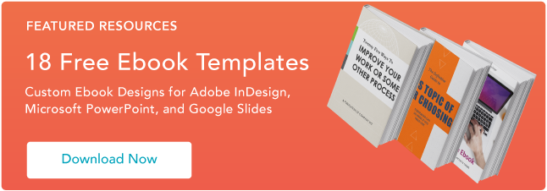](https://www.hubspot.com/cs/c/?cta_guid=ca1346c1-5636-4440-aead-9f82983aaa95&placement_guid=c98bd915-d4fb-4469-8480-cf2163dd4190&portal_id=53&canon=https%3A%2F%2Fblog.hubspot.com%2Fmarketing%2Fwhat-is-a-whitepaper-examples-for-business&redirect_url=APefjpHY3b8X27_fbSpcOqTm3nxaXHuEn0DEfclrVCREpWOIPmoL0td8naneCBR-TuWz04W27uMg4B8z2kJn2sh0SXHwNRc38lN0Q8UeO8tXs-eRPIf1oy_2OuIKz0Y9YNRgmUTFKq3E-1POOmnqMI2vQUQ5XPVPCg&click=8f319dc3-e92c-4a59-adea-41925b2aad8e&hsutk=a8e251279e635ec198f77ad9049713ba&signature=AAH58kEZOw2zZ-yKPV6cbE1L6UTQd0iuEQ&utm_referrer=https%3A%2F%2Fwww.google.com%2F&pageId=1069658569&__hstc=20629287.a8e251279e635ec198f77ad9049713ba.1570108190422.1570108190422.1570108190422.1&__hssc=20629287.1.1570108190423&__hsfp=1214840526&contentType=blog-post)